1. **Rewarding Most Loyal Users**

* select * from users order by created_at asc limit 5;

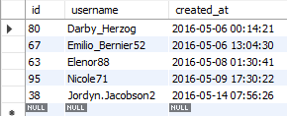

1. **Remind Inactive Users To Start Posting**

* select id,username from users where id not in (select user_id from photos);

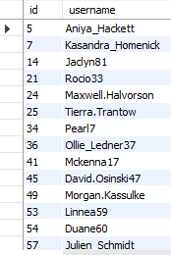 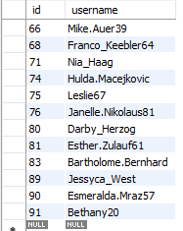

1. **Declaring Contest Winner**

* select photo_id,d.*, count(distinct b.user_id) as total_likes from likes as b join photos as c on b.photo_id=c.id join users as d on d.id=c.user_id group by photo_id order by total_likes desc limit 1;

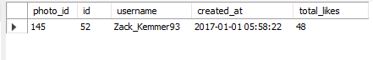’

1. **Hashtag Researching**

* select tag_name , count(photo_id) as total_hashtags from tags as t join photo_tags as pt on t.id=pt.tag_id group by tag_name order by total_hashtags desc limit 5;

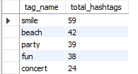

1. **Launch Ad Campaign**

* select date_format(created_at, '%a') AS Day from users Group by date_format(created_at, '%a') ORDER By count(date_format(created_at, '%a')) DESC LIMIT 1 ;

1. **User Engagement**

* select count(id) as total_photos,count(distinct user_id) as total_users , (count(id)/count(distinct user_id)) as avg_user_posts from photos;



1. **Bot And Fake Accounts**

* select u.* ,l.user_id ,count(l.photo_id) as total_likes from likes as l left join users as u ON u.id=l.user_id left join photos as p ON p.id=l.photo_id group by l.user_id having (select count(id) from photos) = total_likes order by total_likes desc;

